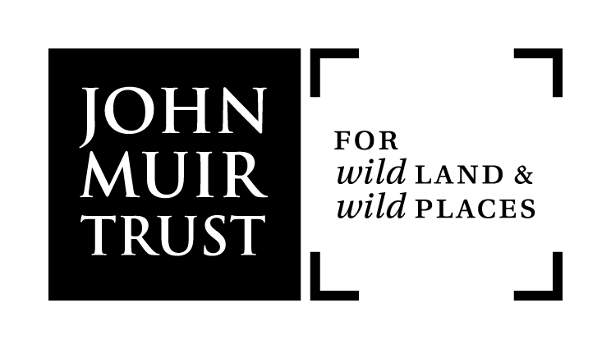

Guidelines for John Muir Trust Local Members’ Groups

- What is a local members’ group

Local members’ groups provide an opportunity for members to come together as like-minded people to share ideas, learn more about the Trust, and about wild land and wild places. The groups are run by volunteers and any member is welcome to get involved. They are intended to offer a range of activities which reflect the interests of local members and provide opportunities to support achievement of Local Group objectives.

- Objectives of a Local Members’ Group
Our Vision is that wild land is protected and enhanced throughout the UK and wild places are valued by all sectors of society. This Vision is ambitious and long term. It provides the foundation for our work and to inspire others. It can only be achieved if we successfully influence and encourage governments, landowners and managers, people living alongside wild land, voluntary organisations and the wider public to accept its merits and realise its ambitions. With that in mind, possible objectives of a local members’ group could include:
- To raise awareness of the Trust to a wider audience and encourage new membership
- Support John Muir Trust campaigns.
- To get involved in practical conservation activities
- Provide feedback and intelligence, especially on relevant local issues, to appropriate staff members and to the Board of the Trust if deemed appropriate
- To raise funds for the Trust through a range of activities

- Setting up a Local Group
A local members’ group is entitled to organise and run itself in the manner that it chooses as long as it is in accordance with the Trust’s overall aims and objectives. The following is extracted from the Trust’s Articles of Association, Paragraph 58:
“Subject to the Trustees’ approval, members may establish local groups to support the objectives and work of the Trust. Any such group duly approved shall be entitled to describe itself as a John Muir Trust Members’ Group and may be organised as the group considers appropriate. The Trust reserves the right to provide guidance and instructions on their organisation and may withdraw the Trust’s approval if the group is not considered by the Trust at its sole discretion, to be operating in accordance with the aims of the Trust”.

  - The Trust has an outline constitution for those groups that wish to be formally constituted. The Trust will however discourage local groups from setting themselves up as a registered charity.
  - The John Muir Trust will provide each local members’ group access to a key member of staff or Trustee to attend one annual meeting per year. The Trust will cover all staff expenses to attend that meeting.
  - The John Muir Trust would hope to offer administrative support of up to a maximum of 2.5 days per group per year to assist in the organising and promotion of activities. This is subject to resource availability within the Trust. Administrative support from the Trust will take the form of assistance and guidance in developing and distributing promotional material.
  - The Trust is also able to assist any start up group by contacting members in the area to encourage interest or support.
  - The John Muir Trust will provide an “affiliated” logo for use by the local members groups. In addition a set of Trust brand guidelines will be provided to each group along with email and letter templates to assist in external communication activity.
  - The Trust will actively encourage local members groups to identify potential links with other organisations with similar or parallel interests in the local area to their mutual benefit. The Trust will where possible also advise if there are any established links with other organisations in the local area. This is especially relevant in less densely populated areas where such relationships may help to broaden potential audiences and make the groups more viable.

- Running a Local Members’ Group
  - John Muir Trust Members Groups are a members’ benefit. The groups should be run by members and should be open to all in a specific geographical area as identified by the organiser(s). Non-members are welcome to attend meetings or events but should be encouraged to become members.

  - Groups must aim to be self-funding. The Trust recognises that Local members’ groups will require to keep a small amount of funds at their disposal; this amount should be at the discretion of the organisers. Any additional funds to not designated for a particular local group activity should be passed onto the Engagement Officer.
  - If required, the Trust may be able to offer a limited amount of financial assistance to each local group in each calendar year to support the activities and ensure the continuation of the group. Any group wishing assistance should contact the Engagement Officer.
  - With agreement of the John Muir Trust the group is entitled to seek small grants from locally based charities or Trusts or other appropriate organisations to enable it to achieve its objectives.
  - Local groups are encouraged to arrange a number of different events throughout each year
  - It is suggested that a small charge is made to cover costs of room hire, etc. If possible, find speakers locally – say, from among your members. If speakers belong to the John Muir Trust, offer them only their expenses in order to keep costs down.
  - Local group meetings don't have to be formal events – sometimes just a chat over a drink in a pub or at someone's house can be just as productive.
  - Organisers should keep a record of the contact details of those attending meetings and events. Data protection legislation requires organisers to ensure they obtain members’ permission to contact them about future events and activities.
  - When organising a meeting or event, it is important to be aware of accessibility in terms of timings, locations and venues.
  - Organisers should be aware of any requirement to undertake a risk assessment when organising events or work parties and should take advice from established venues or appropriate contacts regarding health and safety procedures.
  - Meetings and events can be promoted by the Trust if the local organiser informs the Trust’s Engagement Officer (or nominated representative) as far in advance as possible, for inclusion in the monthly e-newsletter and the local groups’ web page.
  - Brief reports of meetings should be sent to the Trust’s Engagement Officer (or nominated representative) for potential inclusion in the Members’ News.
  - In addition to routine notices and reports about meetings, Local Group Organisers should feel free to raise any relevant local environmental issues to the attention of the Trust Engagement Officer, Trustees or Chief Executive.

Please contact Fiona Mackintosh on 01796 470080 or email fiona.mackintosh@jmt.org for more information
A toolkit of templates is available to support promotional and communication needs of local members’ groups
Groups are responsible for ensuring that they comply with the Data Protection Act (see http://www.ico.gov.uk/for_organisations/data_protection.aspx for further information)

