ReRoute Recommendations – How do they apply to where you work?

From the Insight ReRoute Recommendations Report, June 2018:
Since 2015, Young Scot and Scottish Natural Heritage have been working in partnership to create and support a strategic co-design panel of young people called ReRoute. The group of volunteers from across Scotland aged 13-24 explored ways of increasing young people’s engagement with Scotland’s biodiversity.

The Insight Report Recommendations are primarily for Scottish Natural Heritage but many apply more broadly to other organisations and the environment sector as a whole [and beyond]. Key recommendations themes:
- Engagement and Experience
- Connection to Local Green Space
- Work and Volunteering
- Online Communications
- Image of Scottish Natural Heritage

“At Young Scot we know that nature and Scotland’s outdoor spaces are very important for young people, and that young people’s views are central to Scotland’s nature, now and in the future.” Louise Macdonald OBE, Chief Executive, Young Scot

Use this table to outline what’s being done in support of these recommendations, and consider what more might be done:
- simply respond to the main Recommendations
- use as a conversation starter amongst colleagues
- look at/map the ‘Scale of Engagement’ model (back-pages) in relationship to what you do
- ask/support a young person already involved with your organisation to respond

Our work/organization: YOUR ORGANISATION | What you do | What you could do
Recommendation 1 Engagement and Experience
Actively engage young people with Scotland’s nature, allowing them to experience it and develop not only an interest, but an investment in it both now and in the future.
Action I
Reframe information about the benefits and experiences young people get from nature so that it is relevant through topics, values and issues that are important to young people.
Focus information on specific themes and topics (such as fitness, socialising, wildlife, enjoying beautiful scenery and art) rather than just nature.
Focus on the benefits that young people gain from nature by promoting campaigns such as Freshspace that highlight the significant benefits of nature for young people’s mental health and wellbeing.
Simplify language and avoid terms such as ‘biodiversity’ and ‘heritage’
Provide suggestions for small achievable actions and behaviour changes that young people can carry out, such as those in ReRoute’s Big Steps for Nature found on www.young.scot/reroute.
Action II
Support the increase in effective delivery of outdoor learning and environmental education
Create a curriculum group that involves young people to share best practice and co-design outdoor learning and initiatives
Ensure that specific Scottish species and contexts are used as examples across every subject – such as case studies of Scottish rather than American bees in biology or the geography of Scotland’s National Parks
Embed outdoor learning as a core, compulsory part of teacher training and practice
Routinely assess schools on quality of outdoor learning as part of their regular assessment
Recommendation 2 Connection to Local Green Space
Ensure young people are invested in and involved in their local green spaces
Action I
Provide opportunities for young people to have a strategic role in managing and promoting nature in urban areas
Identify with young people specific ways that they can be involved in decisions which affect their local urban nature
Support junior ranger programmes, specifically in areas of multiple deprivation
Ensure that young people co-produce the implementation of SNH’s proposals for new Urban Nature parks
Action II
Highlight and celebrate the nature that young people already access
Ensure 50% of images used in publications and documents show nature in urban areas
Create a programme of urban junior rangers to champion their local area and encourage all young people to enjoy and experience nature
Develop a competition that encourages young people who aren’t engaged with nature to celebrate and promote nature in their local area
Action III
Reduce barriers young people may face to accessing local nature
Establish local ‘kit libraries’ in key urban areas that provide waterproof clothing, footwear and essential kit for spending time outdoors
Develop the potential of the Future Routes fund for young people to overcome barriers to engage with local green spaces
Recommendation 3 Work and Volunteering
Improve job and volunteering opportunities for young people
Action I
Improve the quality and promotion of job and volunteering opportunities in Scotland
Promote the range of employment and volunteering opportunities, highlighting the different skills, topics and locations available in short online videos
Centralise information about volunteering opportunities onto one platform
Attend careers fairs to actively promote opportunities
Cover out of pocket expenses for young people volunteering or attending interviews
Action II
Ensure at least 5% of SNH employees are under the age of 26 by 2020
Champion SNH’s strategic approach and policies to ensure young people can be recruited based on competency rather than amount of experience
Increase the amount of paid entry level positions available for young people
Increase the length of contracts of graduate placements to allow more stability and encourage career progression
Action III
Celebrate the success and contribution young people make to the environment sector
Highlight success of young employees in internal and external communications at least once a month
Sponsor awards that highlight young people in a range of jobs in the environmental sector
Increase funding for accreditations for young people contributing to Scotland’s nature informally through awards such as the John Muir Award and Duke of Edinburgh Award
Recommendation 4 Online Communications
Use online communications and social media platforms more effectively to engage young people
Action I
Involve young people in creating online content
Have young people takeover SNH’s social media accounts at key events and opportunities through the year
Host young bloggers, vloggers and writers on SNH platforms at least once a month
Work with younger staff members and volunteers to identify and promote content that links to current affairs and campaigns e.g. using the #stoptheplastictide to share content whilst people are interested in
Blue Planet
Promote SNH’s new website, nature.scot, to young people
Action II
Use a range of social media platforms relevant to young audiences
Use different platforms to engage different demographics – for example Snapchat and Instagram are very visual and are better ‘entry points’ for people who are less engaged with nature, whereas Facebook and Twitter allow for more information and level of detail to be shared
Ensure staff receive regular up to date training on using the rapidly changing platforms
Enable a range of staff to highlight the work they do in a personal, relatable way on SNH’s social media accounts
Action III
Share a variety of content in different formats
Share information in concise formats, for example listicles, infographics, and images which are more familiar and accessible to young people
Link information to current events and trending topics
Ensure language is simple, jargon-free and easy to understand with good links to more detailed information
Action I
Provide a platform to amplify young people’s views and voices
Include young people as a specific stakeholder in decision making and Co-design (for example being involved in planning Scotland’s biodiversity goals after 2020)
Identify two key areas to involve young people through co-design and co-production per unit/activity within SNH
Actively support someone under the age of 26 on SNH’s Governance structures such as the Board,
Leadership Groups and wider Strategic Groups such as the Environment and Economy Leaders Group
Action II
Engage with a wider range of young people
Develop and use the Scale of Engagement with young people, staff and stakeholders (below)
Review SNH’s policies and practices to ensure they actively involve young people across SNH’s areas of work
Action III
Develop SNH’s image for young people as a key audience
Consider rebranding SNH and involve young people and recent recruits in this process
Ensure that at least 50% of photographs used in SNH’s publications and media depict a diverse range of young people
Improve SNH’s image library to reflect up to date young people, technology and activity
Simplify language and avoid jargon in public communications

Scale of Engagement
To successfully encourage deeper, invested interest in Scotland’s nature, it is important to acknowledge what ‘level’ the young people are starting at. For example if someone has a minimal level of engagement with the environment, encouraging them to watch a video about camping in Scotland may be more realistic than encouraging them to go on a wild camping trip.
The scale also helps identify the small steps young people can take to transition between levels and develop a more invested interest (see model below).

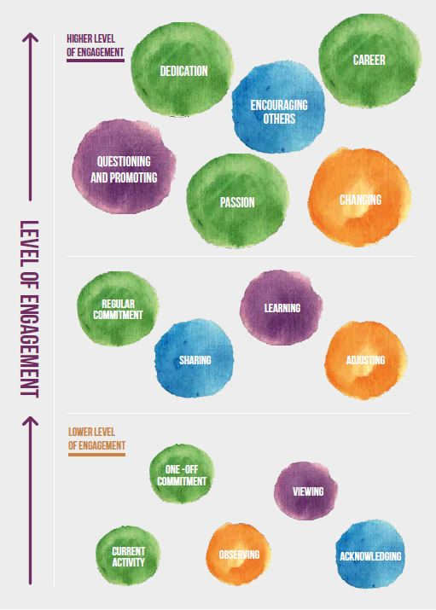
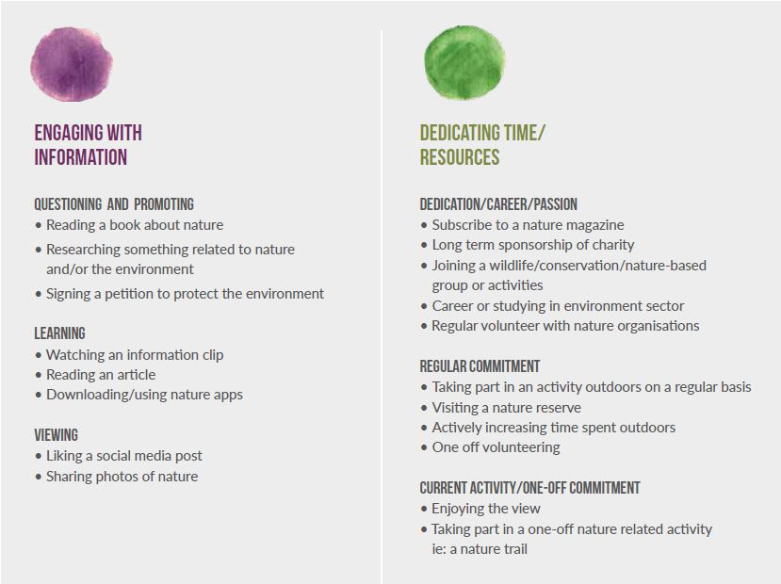
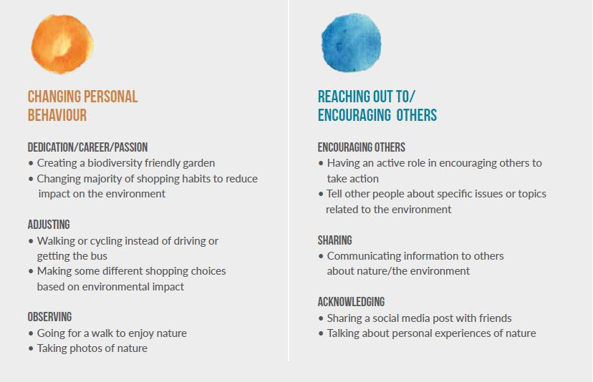
Original model can be found at https://www.youngscot.net/wp-content/uploads/2018/06/YS_ReRoute_Recommendations_Online-1.pdf

